Algebra 2
Semester Exam REVIEW

SHOW ALL YOUR WORK

- Sketch the graph of the square root parent function.

2. Write the equation for the graph below.

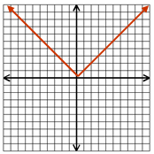

3. What is the equation of y = x² once it has been reflected, shifted up 1 and left 7 units?

4. What is the function f(x) = x² after the transformations: a compression of ¼ and a shift up 2 units?

5. Sketch the graph of the function: f(x) = – (x – 2)²

6. Name the transformations for the function: f(x) = 5(x + 7)²
7. Evaluate the function for f(7): f(t) = –2t² + 9t

8. Evaluate the function for p(x + 2): p(x) = 4x – 5

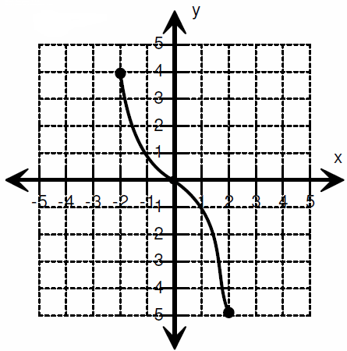
9. Find f(2) from the graph.

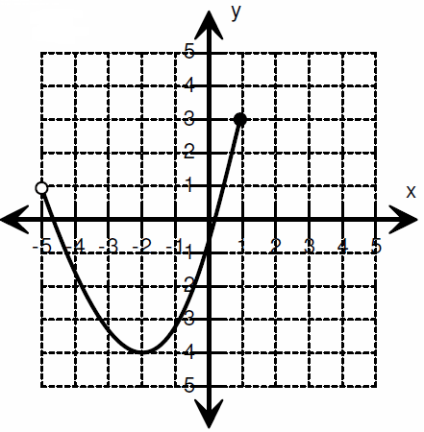
10. Find the range for the graph.

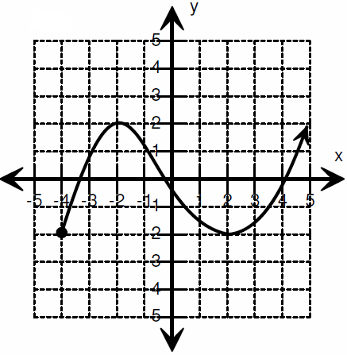
11. Find the domain for the graph.

12. Write the domain [-2, 5) in inequality notation.

13. Solve for x: 2(x + 4) + 6 = 14
14. Solve for x: 4 + 3(2x + 3) = 12x – 5

15. Solve the absolute value equation: $2\left|x-5\right|=6$

16. Solve the absolute value equation: $\left|3x-6\right|+4=7$

17. Solve the absolute value inequality: $2 \left|4x-8\right| ≥8$

18. Factor the quadratic expression: x² – 9x + 20

19. Factor the quadratic expression: 3x² + 13x – 10

20. Factor the quadratic expression: 4x² + 14x + 12

21. Solve the quadratic equation by taking a square root: 5x² – 6 = 134

22. Solve the quadratic equation by taking a square root: -4(x² – 3) = -88

23. Solve the quadratic equation by taking a square root: -3 + 2x² = 49

24. Solve the quadratic equation by completing the square: x² + 14x = -34

25. Solve the quadratic equation by completing the square: 3x² – 18x + 9 = -6

