Linear Equations Practice #1
Find the equation of each line in slope–intercept form.
- The line has a slope of 7 and a y−intercept of -2.
- The line has a slope of -5 and a y−intercept of 6.
- The line has a slope of −14 and contains the point (4, -1).
- The line has a slope of 23 and contains the point (12,1).
- The line has a slope of -1 and contains the point (45,0).
- The line contains points (2, 6) and (5, 0).
- The line contains points (5, -2) and (8, 4).
- The line contains points (3, 5) and (-3, 0).
- The line contains points (10, 15) and (12, 20).
- 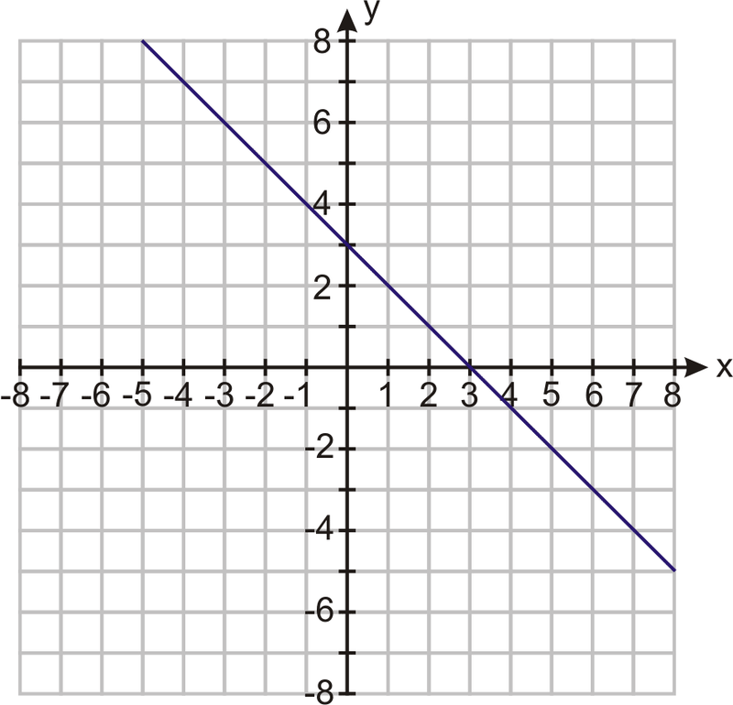
- 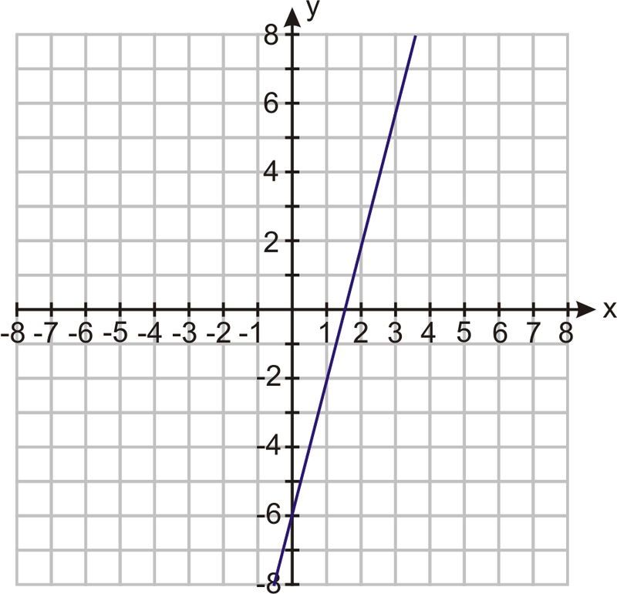
- 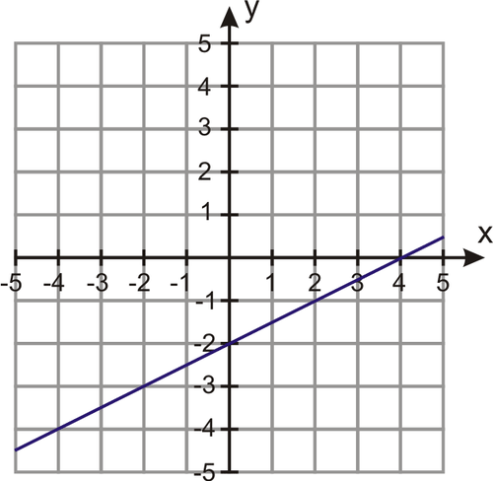
- 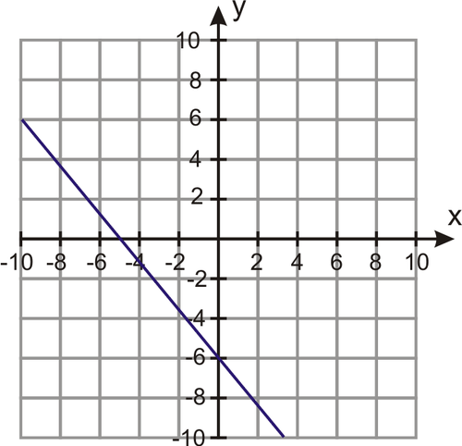
- 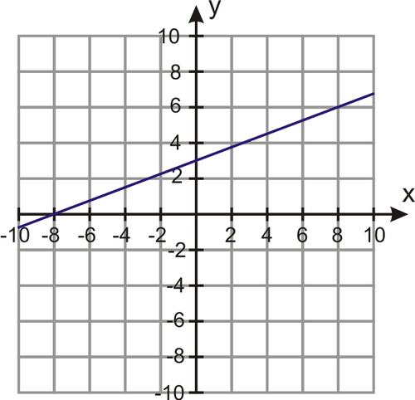

Graph the following equations.
- y=3x−8
- y−2=−2(x+3)
- 2y=6x+8
- y=3/2x+5
- y+6=2/3(x+3)
- 3y+5=4(x−1)

