Relations & Functions Handout
For Questions 1 - 4, give the domain and range. Make a mapping diagram for each relation. Determine if each relation is a function. If it is not a function, explain why.
- (2, 4) (4, 6) (6, 8) (3, 4) (5, 7) (8, 2)
- (-1, 6) (0, 4) (-4, 0) (-1, -6) (-3, -8)
- (Jim, Kitty) (Joe, Betty) (Brian, Alice) (Jesus, Anissa) (Ken, Kelli)
- (Jim, Alice) (Joe, Alice) (Brian, Betty) (Jim, Kitty) (Ken, Anissa)
For Questions 5 - 6, give the domain and range. Write each as a set of ordered pairs. Determine if each relation is a function. If it is not a function, explain why.
- 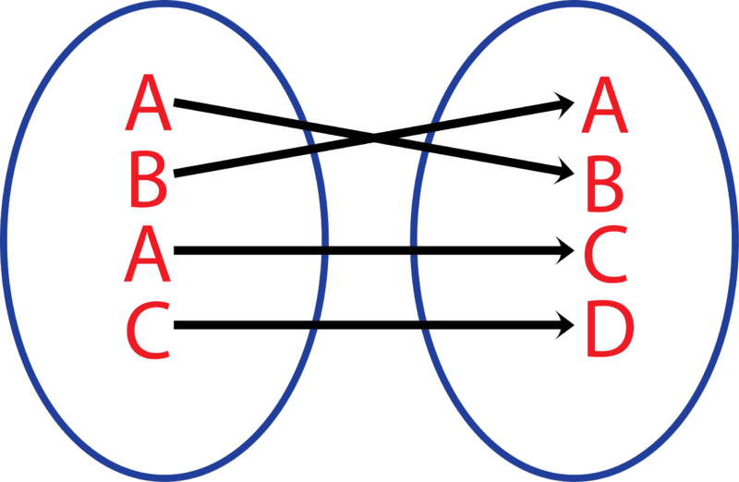
- 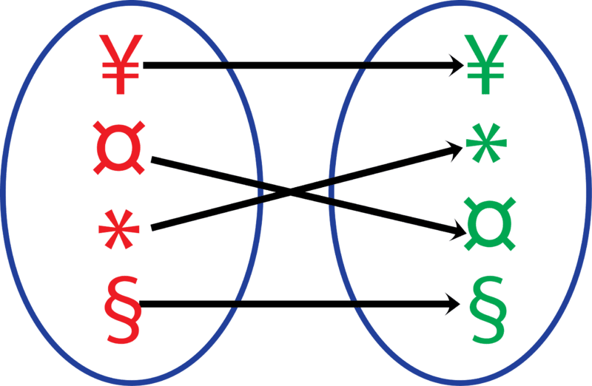

For Questions 7 - 9, give the domain and range. Determine if each relation is a function. If it is not a function, explain why.
- 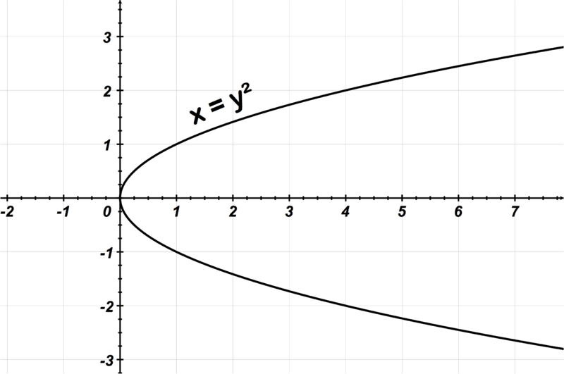
- 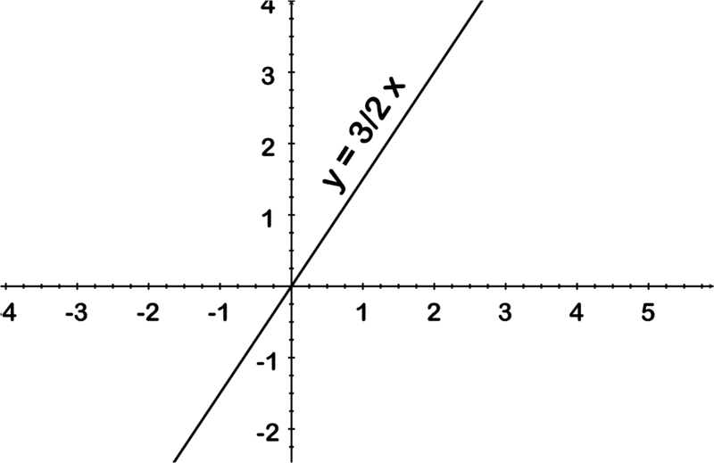
- 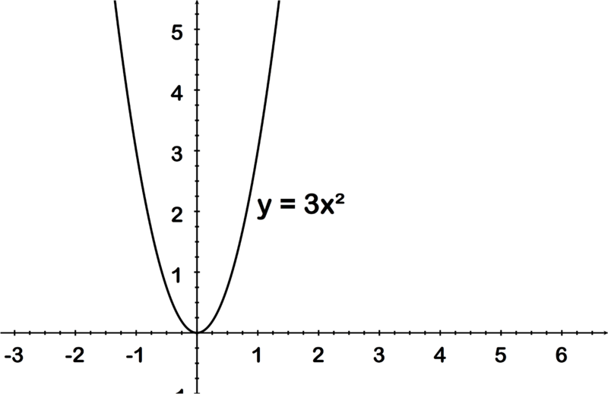

- At a Prom dance, each boy pins a corsage on his date. Is this an example of a function?
- Later, at the same dance, Cory shows up with two dates, does this change the answer?
For each function, evaluate f(0),f(12),and f(5)
- f(x)=2x+1
- f(x)=−2x+1
- f(x)=−2x2+3
- f(x)=5x2−2x+1

